HANDS-ON 10:Unit Testing Angular Applications — Jasmine, Karma & TestBed
Project Structure:
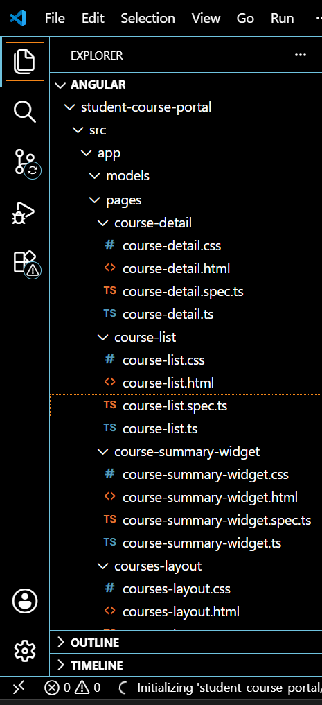
Course-list.spec.ts
import { ComponentFixture, TestBed } from '@angular/core/testing';
import { By } from '@angular/platform-browser';
import { provideRouter } from '@angular/router';
import { provideMockStore, MockStore } from '@ngrx/store/testing';

import { CourseList } from './course-list';

describe('CourseList', () => {
let component: CourseList;
let fixture: ComponentFixture<CourseList>;

beforeEach(async () => {
await TestBed.configureTestingModule({
imports: [CourseList],
providers: [
provideRouter([]),
provideMockStore({
initialState: {
course: { courses: [], loading: false, error: null },
enrollment: { enrolledCourseIds: [] }
}
})
]
})
.compileComponents();

fixture = TestBed.createComponent(CourseList);
component = fixture.componentInstance;
fixture.detectChanges();
});

it('should create', () => {
expect(component).toBeTruthy();
});

it('should show loading indicator when store loading state is true', () => {
const store = TestBed.inject(MockStore);
store.setState({
course: { courses: [], loading: true, error: null },
enrollment: { enrolledCourseIds: [] }
});
fixture.detectChanges();

const loadingEl = fixture.debugElement.query(By.css('p'));
expect(loadingEl.nativeElement.textContent).toContain('Loading courses');
});
});
App.spec.ts
import { ComponentFixture, TestBed } from '@angular/core/testing';
import { provideRouter } from '@angular/router';

import { App } from './app';

describe('App', () => {
let component: App;
let fixture: ComponentFixture<App>;

beforeEach(async () => {
await TestBed.configureTestingModule({
imports: [App],
providers: [provideRouter([])]
})
.compileComponents();

fixture = TestBed.createComponent(App);
component = fixture.componentInstance;
fixture.detectChanges();
});

it('should create the app', () => {
expect(component).toBeTruthy();
});

it('should render title', () => {
expect(component).toBeTruthy();
});
});
Courses-layout.spec.ts
import { ComponentFixture, TestBed } from '@angular/core/testing';
import { provideRouter } from '@angular/router';

import { CoursesLayout } from './courses-layout';

describe('CoursesLayout', () => {
let component: CoursesLayout;
let fixture: ComponentFixture<CoursesLayout>;

beforeEach(async () => {
await TestBed.configureTestingModule({
imports: [CoursesLayout],
providers: [provideRouter([])]
})
.compileComponents();

fixture = TestBed.createComponent(CoursesLayout);
component = fixture.componentInstance;
fixture.detectChanges();
});

it('should create', () => {
expect(component).toBeTruthy();
});
});
Course-list.spec.ts
import { ComponentFixture, TestBed } from '@angular/core/testing';
import { provideRouter } from '@angular/router';

import { CourseList } from './course-list';

describe('CourseList', () => {
let component: CourseList;
let fixture: ComponentFixture<CourseList>;

beforeEach(async () => {
await TestBed.configureTestingModule({
imports: [CourseList],
providers: [provideRouter([])]
})
.compileComponents();

fixture = TestBed.createComponent(CourseList);
component = fixture.componentInstance;
fixture.detectChanges();
});

it('should create', () => {
expect(component).toBeTruthy();
});
});
Course-detai.spec.ts
import { ComponentFixture, TestBed } from '@angular/core/testing';
import { provideRouter } from '@angular/router';

import { CourseDetail } from './course-detail';

describe('CourseDetail', () => {
let component: CourseDetail;
let fixture: ComponentFixture<CourseDetail>;

beforeEach(async () => {
await TestBed.configureTestingModule({
imports: [CourseDetail],
providers: [provideRouter([])]
})
.compileComponents();

fixture = TestBed.createComponent(CourseDetail);
component = fixture.componentInstance;
fixture.detectChanges();
});

it('should create', () => {
expect(component).toBeTruthy();
});
});
Header.spec.ts
import { ComponentFixture, TestBed } from '@angular/core/testing';
import { provideRouter } from '@angular/router';

import { Header } from './header';

describe('Header', () => {
let component: Header;
let fixture: ComponentFixture<Header>;

beforeEach(async () => {
await TestBed.configureTestingModule({
imports: [Header],
providers: [provideRouter([])]
})
.compileComponents();

fixture = TestBed.createComponent(Header);
component = fixture.componentInstance;
fixture.detectChanges();
});

it('should create', () => {
expect(component).toBeTruthy();
});
});
OUTPUT:
